Tuesday March 3, 2015
We had a great day exploring the number 100!
In the morning, the students enjoyed using 10-frames to count 10 groups of 10 different craft materials to decorate their 100th Day of School crowns. Then we read some 100 Day of School stories and practiced counting by 1’s, 10’s and 5’s to 100. In the afternoon, the students used 10-frames and hundreds charts to make the following:
- a mural with 100 handprints
- trail mix with 10 x10 different items
- a gimp necklace with 100 fruit loops
- a KB monster with 100 eyeballs
- structures with 100 blocks
- 10 sand and snow castles with 10 decorations on each
- paper chains with 100 links
- A rainbow with 100 bingo dabs
- A gumball machine with 100 gumballs
- A snowman with 100 buttons
- a collage with 100 nature items
We also:
- moved our bodies for 100 seconds straight
- did 100 yoga moves throughout the day
- collectively read 100 books
- made a self-portrait of ourselves at 100 years old
- made 100 snowshoe footprints in the snow
- sat still for 100 seconds
- wrote about the things we would and would not like to eat 100 of
- made a list of 100 things we can do
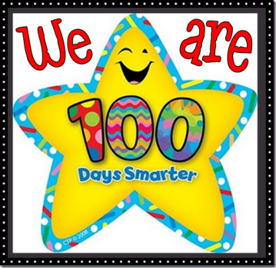
- made a collective wish list of 100 things we would love from the Sears toy catalogue
- weighed 100 chain links with rocks
- collectively wrote 100 sight words
- observed how much snow melts in 100 minutes
- sorted 100 letters and numbers in the sensory bin
- And tomorrow we will share our 100 day collections!

It was a fun and busy day of counting, eating, exploring, playing, and learning. We will continue for the morning tomorrow because students still want to explore some more activities.
Ask your child which part of the day was their favourite and which activities they participated in. Enjoy sharing ongoing conversations about the number 10 and 100 at home and thanks again for your participation in this fun adventure.

Ms. Ferren and Ms. Hewitt

