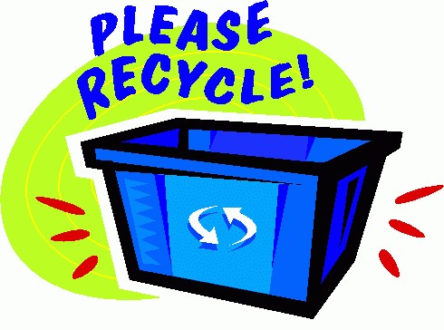
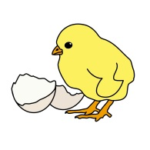
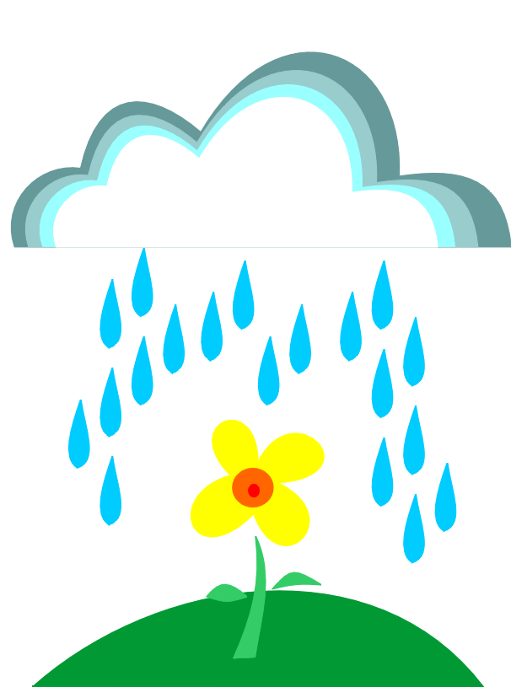
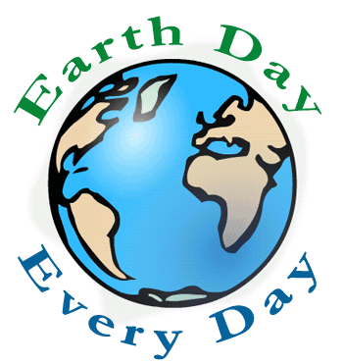
KB in April

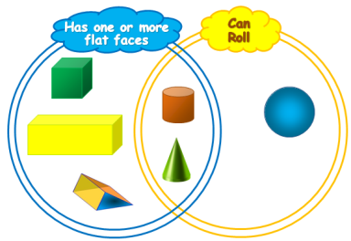
Math: 2D and 3D Shapes / Number Sense
- Identify, describe, explore, sort and compare 2D shapes and 3d figures
- Build 3D structures and begin to recognize 2D shapes and 3D figures within
these structures
- Identify and compare sets with more, fewer, or the same number of objects
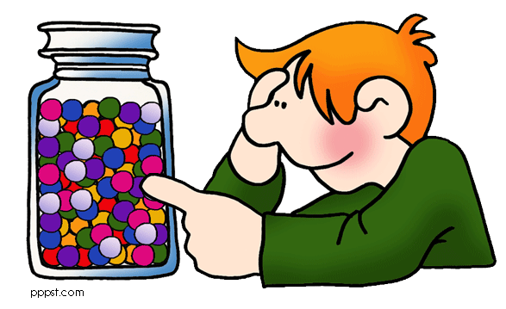
- Recognize some quantities without having to count
- Develop strategies for composing and decomposing numbers to 10
- Investigate addition and subtraction in everyday activities
- Begin to use information to estimate the number in a small set

Language:
- Use specialized vocabulary for a variety of purposes
- Respond to a variety of materials read aloud to them
- Demonstrate knowledge of the letters of the alphabet in a variety of different contexts
- Retell information from non-fiction in proper sequence
- Use reading strategies to make sense of unfamiliar texts
- Experiment with different writing forms
- Use classroom resources to support writing (i.e. Word wall, dictionary)

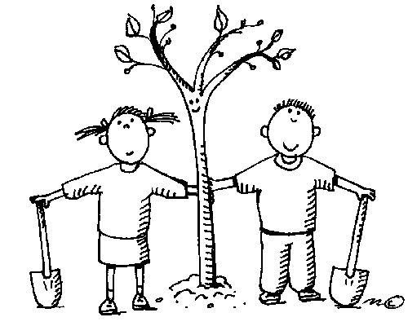
Science: Care and Respect for Our Environment
- BIG IDEA: Children are connected to others and contribute to their world
- Identify ways that you can care for and show respect for their environment
- Participate in environmentally friendly activities in the classroom and in the school yard
- Understand the difference between living and non-living things

The Arts:
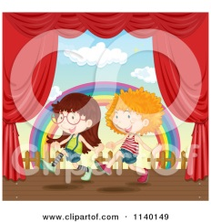
- Explore different elements of design, drama, and music and the various tools, materials, and
processes we can use
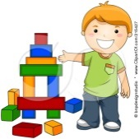
- Use problem-solving skills and imagination to create art forms
- Express responses, make connections, and communicate understandings through art
- Demonstrate interest and a sense of accomplishment in drama and dance

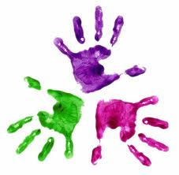
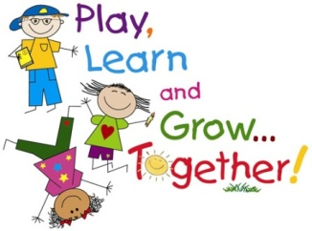

Tell me and I forget. Teach me and I remember.
Involve me and I learn.

