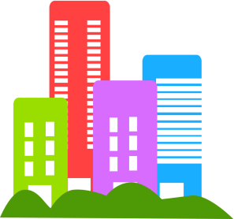
Wednesday May 20, 2015
Dear KB Families,
Today, we are sending home a photo of the community building your child will learn about and present to the class. As requested in our May 14th note last week, we are hoping your child will have an opportunity to visit this place with you by Monday May 25th. We have included some focus questions below to help guide the purpose of your visit.
During the week of May 25th, your child will build a structure at school of their community building and share their learning with their peers. We can’t wait to see what experiences they bring to the group.
Thanks so much for supporting this important learning opportunity!
The KB Kinder Team (Ms. Ferren and Ms. Hewitt)

Focus Questions about My Community Building

- What is the name of your community building?
______________________________________________________________________________

- Who works there?

- What happens there?
______________________________________________________________________________

- Why is this an important place/service to have in our community?
______________________________________________________________________________

- What did you notice about this place that you would like to share?
______________________________________________________________________________

- What questions/wonderings do you still have about this place?
______________________________________________________________________________

Can you draw a picture of your community building?

