T.W.A.S.
(This Week at School)
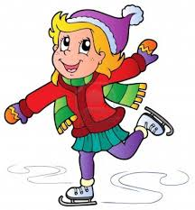
Friday February 13, 2015
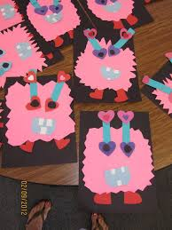
Skating and our Valentines celebrations were both a big hit this week. The students are getting so much better at skating. It’s amazing how quickly they learn. Many of them can now stand on their own and some are shuffling along independently the entire time. A big thank you goes out to our few parent volunteers who show up each week to help us. We wouldn’t be able to do it without you Nikki, Matt, Crystal, and Sonja. Thank you for taking time during your lunch to come and help us. We are also indebted to our teaching colleagues who have so graciously provided older students for us to take away from their work for 2 hours to help us walk the students there, tie skates, and help them skate on the ice. The students made cookies for our student helpers to show them our appreciation. Please consider joining us on February 25th so the students don’t miss out on this awesome opportunity.
Our Valentine’s party was a lot of fun. The students enjoyed making heart shaped sugar cookies and their heart crown. They loved decorating their Valentine’s bag, and most of all enjoyed delivering and receiving Valentines. After skating, we watched Franklin’s Valentine and enjoyed hot chocolate, popcorn, home-made cookies, fruit and veggies. The kids played in the snow table with heart shaped cookie cutters, spray bottles full of coloured dye, and dessert containers. They pretended they were making snow cones, snow cupcakes, and snow cookies. They also enjoyed making pretend muffins, cookies, and cakes with our chocolate and raspberry play dough. And they dug for heart treasure in the sand and created heart sculptures and decorated them. We have cornmeal in our sensory table right now and the students have enjoyed scooping, pouring, measuring, using funnels, and filling cupcake liners, pots, pans, and trays with cornmeal. It’s been a week full of sensory activities and open-ended play, which the children love.
LITERACY
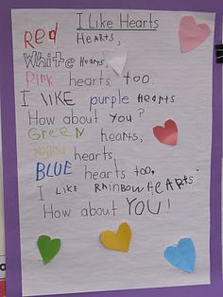
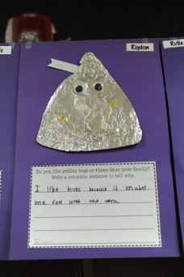
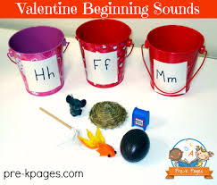
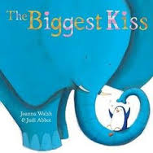
We read many different Valentine’s stories (Happy Valentine’s Day Mouse, How Do Dinosaurs Say I Love You, The Perfect Hug, The Biggest Kiss, and Love is a Handful of Honey) and have incorporated literacy into a variety of open-ended playful explorations. Students enjoyed: making a list of things they love, putting alphabet hearts in order, finding sight words in leveled books, digging for letters and sight words in our rose petal sensory bin, searching for sight words and letters in our pink sand, sorting objects into heart shaped bins according to their number of syllables, and matching hearts that rhyme. Today, after reading 2 different books about hugs and kisses, we asked each student to choose which they prefer more from their family – hugs or kisses. Then, the students wrote about it and made a cute craft to go along with their writing. We also learned 2 different poems and practiced finding our letter of the day and sight words of the day inside our poem each day.

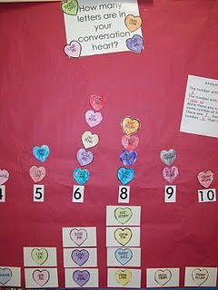
MATH
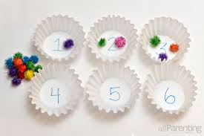
We gave each student a candy heart with words on it and asked them to identify the letters and sounds and then count the letters on their heart. They represented their number on a 10-frame and practiced printing their number. The next day, we modeled how to make a concrete graph to show how many letters were on each of our hearts and then practiced reading our graph. The next day, the students wrote their message on a paper heart and made a picture graph to show how many letters were on their heart in order to demonstrate their learning from the previous 2 days. During playful explorations, the students also enjoyed a variety of open-ended math activities such as: finding the area and perimeter of foam hearts using manipulatives; sorting and making patterns with Valentine’s candy; matching numbers to symbols (tallies, 10-frames, dots) on different hearts to show all the ways to represent different numbers; conducting probability experiments with coloured hearts in paper bags; measuring the length of hearts with manipulatives; exploring capacity in the sand, snow, and sensory tables; and making love bug monsters using different shapes. For Family Day weekend, we are sending home a family math activity for you and your child to complete. Please return it on Tuesday. Thanks.
FOREST SCHOOL ADVENTURES
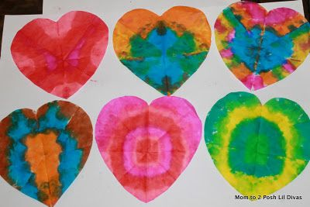
Due to the extreme cold weather several days this week, we were not able to go outside as often as we usually do. However, on the days when we did get outside, the children had a lot of fun exploring a variety of different activities: snowballs on the parachute, broomball, tug of war in the snow, crazy carpeting, digging tunnels, hopping on stepping stones, crawling through tunnels, searching for letters in the snow, painting words and letters in the snow, writing on the school with snowballs, and making pretend bucket of soup with play food and snow. We are hoping to get some relief from these frigid temperatures so we can get outside for our regular learning outdoor block next week.
REMINDERS
- Our next library day is Wednesday February 18th.
- Monday is a holiday for Family Day. Enjoy time with your family and please remember to complete the math activity we are sending home today.
- We will be making pancakes on Tuesday February 17th to celebrate Pancake Tuesday.
- February Scholastic orders are due on Wednesday February 18th.
- We will be celebrating Chinese New Year on Thursday February 19th.
- Friday February 20th is our ASES Winter Fun Day. Students will be outside most of the day. Please dress your child in warm layers and waterproof mitts and boots so they will be warm and cozy all day.
- Report cards go home on Friday February 20th.
- International Angelman Day is on Saturday February 15th with fundraising events starting at 1:00 at the Minden Arena. Public Skating and dinner from 5:30-7:30. Geocaching, live music, bake sale, face painting and more. Join in the fun and help “Catch the Cure” for our 3 local children with Angelman’s Syndrome.
Happy Valentine’s Day and Happy Family Day! Enjoy the weekend with your beautiful children,
Ms. Ferren, Ms. Hewitt, and Ms. Bain

