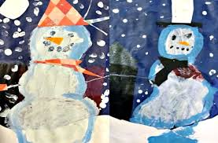
T.W.A.S.
(This Week at School)
Friday February 6, 2015
It’s been a full-moon week in KB! We are hoping everyone gets lots of sleep this weekend and returns to school on Monday ready to play respectfully, share and take turns, use calm indoor voices, keep hands off, listen mindfully, and make good choices . We have re-instated our daily social skills lessons to help remind the children how to be “the best ME they can be”. We have also spent more time doing yoga and deep breathing each day and have brought back our daily “check in” to help students figure out what they might need to better self-regulate. Interestingly, when we are outside, there is less need for any of this, so we might just have to move our teaching and learning outside permanently. We’ll see what Monday brings!
SCIENCE
We have been learning about the scientific process and did some snow and ice melting science experiments this week that the kids loved. The students wondered how snow melts so we decided to conduct an experiment. They made predictions, we gathered materials (blow dryer, coffee, hot water, cold water, sugar, salt, lamp, flashlight, fan), and we set up different experiments. The students described their snow before we started and watched with magnifying glasses to see how their material changed the snow. They recorded their observations with paintings, drawings, sentences, and labels.
We have been practicing making predictions by hiding objects inside mittens and using our sense of touch to make reasonable predictions about what it is.
We also investigated different materials – aluminum foil, plastic, cloth, and paper – by determining which material melted ice fastest. Ask your child what they discovered.
At home, you can help by encouraging your child to wonder and ask questions and then make predictions before conducting an investigation to seek out the answer (i.e. I wonder if my car will sink or float in the bathtub)
LITERACY
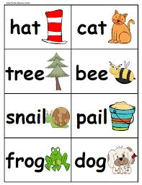
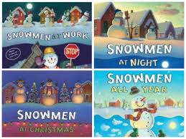
We read 3 different books by the same author - Snowmen at Night, Snowmen at Work, and Snowmen all Year - and looked at similarities and differences. Before reading, we brainstormed what we thought snowmen might do at night, or where they might work, or what they might do the rest of the year. We have been learning how to make lists, so we made a group list to reflect our thinking. Then we read the story and added new ideas from the story to our list. Afterwards, students chose what kind of snowman to make – potato print snowman, chalk snowman, cut out snowman, coffee filter snowman, play dough snow man, real snow snowman, sand snowman, and sponge paint snowman. They added detail to show what their snowman does at night, where it works, and what it does throughout the year. Then they wrote about it using beginning sounds. At home, please continue to practice letters, sounds and sight words. It would be helpful to also practice rhyming and syllables whenever you can to help develop phonemic awareness.
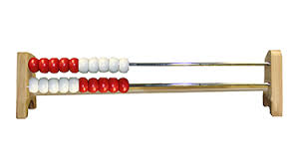
MATH
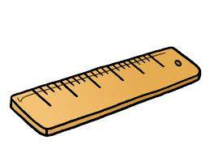
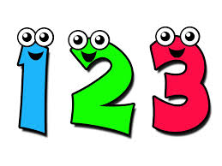
We continue to work on numbers – recognizing them, reading them, writing them, representing them with concrete materials, counting 1:1 and practicing mental math using rekenreks (like an abacus). We asked the children to look around the house, in the car, on their clothing, and in the food cupboards for numbers. They didn’t believe us that they could find numbers everywhere they went. So, we are turning this into a homework assignment. This weekend, please help your child look around for numbers and then get them to draw, take a photo, cut out a picture, or write about one of the numbers they found and where they found it. We are hoping this helps them understand the importance of numbers and connects learning to real-life. We thank you in advance for helping with this task. We have also introduced number problems and the students are having fun choosing tools to solve their number problem. On groundhog day, we asked them to pretend to be groundhogs. Then we asked them to partner up with another groundhog buddy and curl up in their burrow together. We asked them to figure out how many paws were in their burrow. After that, we asked them to figure out how many eyes, noses, mouths, and ears were in their burrow. At home, you can help your child by asking them how many legs are at the dinner table or how many hands, eyes, forks, etc. If your child uses mental math, be sure to ask your child to tell you how they figured it out.
We began a new unit on measurement this week. We measured the snow depth in various spots throughout the forest – 47 cm is the deepest we’ve found so far. We have also been measuring the air and snow temperature each day. Today, the students weighed snow and then weighed the water after the snow melted. And they experimented with capacity making predictions about how much water would be left in the container after the snow melted.
REMINDERS
- We went to the library on Wednesday. Our next library day is Wednesday February 11th.
- We are having a Valentine’s Celebration on Wednesday February 11th. If your child is bringing Valentines, please make sure they bring enough for everyone. We have 27 students in our class – 14 boys and 13 girls if that matters. Please leave the “To” part blank or address it “To a friend” rather than using individual names. Please consider letting your child sign all of their Valentines on their own as this is excellent practice for writing their name. Remind them to use lower case letters only except for the first letter.
- We will be skating on Wednesday February 11th. Please send your child’s skates and helmet in a separate bag that they can carry to the arena independently. If you have a Criminal Record Check on file and are able to join as a volunteer please let us know with a note in your child’s Note Tote.
- Please dress your child in red, white, pink, or hearts next Friday February 13th to earn points for their spirit team.
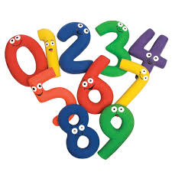
- February Scholastic orders are due on February 18th. We are still waiting for January orders to arrive – we placed the order later than expected. It should be here by the end of next week. Thanks for your patience.
- Have your child search for numbers this weekend and return their findings on Monday. Thanks
- International Angelman Day is on Saturday February 15th. There are 3 children in our community with Angelman’s Syndrome (2 of them are students at ASES). Fundraising events starting at 1:00 at the Minden Arena. Public Skating and dinner from 5:30-7:30. Geocaching, live music, bake sale, face painting and more. Join in the fun and help “Catch the Cure” for our 3 local children with Angelman’s Syndrome. If your child wants to collect donation money to sponsor their skate as a way of contributing, please let us know and we can send home a sponsor form. This is not an obligation but an opportunity for those interested!

