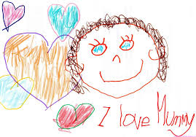
KB in May
Personal/Social: Community; Awareness of Surroundings
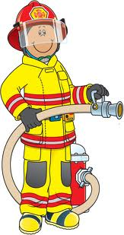
- Recognize people in their community and talk about what they do
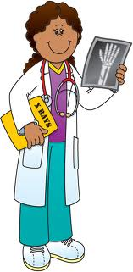
- Recognize places and buildings within their community, both natural and human-made and talk about their functions
- Develop an awareness of ways in which people adapt to the places in which they live
- Identify their own interests and preferences and express their thoughts
Math: Measurement + Patterning
- Measure and compare length, mass, capacity, area, and passage of time using non-standard and standard units through free exploration, focused exploration and guided activities
- Explore, recognize, describe, and create patterns using a variety of materials in different contexts
Language:
- Use specialized vocabulary
- Ask questions for a variety of purposes
- Use language to talk about their thinking
- Retell information from non-fiction materials
- Identify personal preferences in reading materials
- Demonstrate an interest in reading
- Make predictions and connections
- Experiment with a variety of writing forms
- Begin to respond critically to animated works
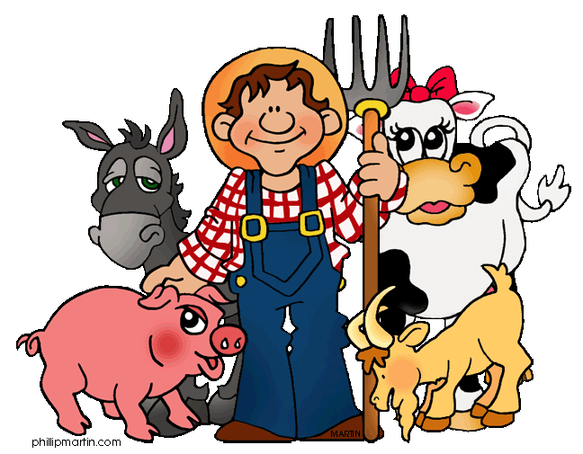
- Communicate ideas verbally and non-verbally about a variety of media materials
Science: Living/Non-Living Things
- Sort and classify groups of living and non-living things
- Identify similarities and differences between environments
- Describe what would happen if something in local environment changed
- Identify ways in which they can care for and show respect for the environment
Arts:
- Explore different elements of drama, dance, and visual art.
- Express their responses to drama, dance and visual art

NOTE: Curriculum expectations are extracted from the Full Day Early Learning Kindergarten Program, 2010-11.

