Tuesday February 24, 2015
Dear KB Families,
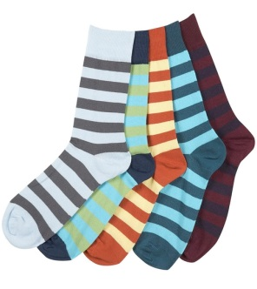
Tomorrow (Feb 25) is Anti-Bullying Day or Pink T-Shirt Day. ASES is showing their support for this worldwide anti-bullying campaign by wearing pink shirts and/or funky socks to “Sock it to Bullying”. Please help your child wear pink or mix-matched socks to help support this cause. We have discussed bullying very mildly in class and will focus on it a bit more tomorrow but feel free to have your own discussion with your child about what this might look like for someone their age. Thanks for your support.
Also, just a reminder that we are skating tomorrow (Wednesday Feb 25). Please send your child with their skates and helmets in a separate bag that they can carry independently.
Thanks so much,
Ms. Ferren, Ms. Hewitt, and Ms. Bain

Tuesday February 24, 2015
Dear KB Families,
Tomorrow (Feb 25) is Anti-Bullying Day or Pink T-Shirt Day. ASES is showing their support for this worldwide anti-bullying campaign by wearing pink shirts and/or funky socks to “Sock it to Bullying”. Please help your child wear pink or mix-matched socks to help support this cause. We have discussed bullying very mildly in class and will focus on it a bit more tomorrow but feel free to have your own discussion with your child about what this might look like for someone their age. Thanks for your support.
Also, just a reminder that we are skating tomorrow (Wednesday Feb 25). Please send your child with their skates and helmets in a separate bag that they can carry independently.
Thanks so much,
Ms. Ferren, Ms. Hewitt, and Ms. Bain

