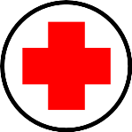
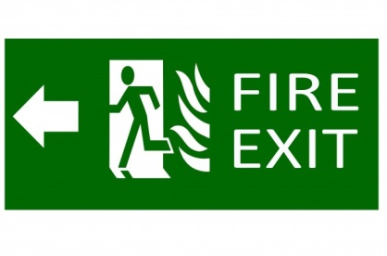
Tuesday May 12, 2015
Dear KB Families,
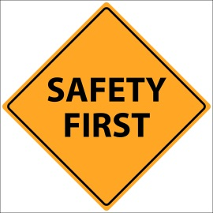
As part of our Health curriculum, we are learning about Safety – school and playground safety, crossing safety, fire safety, road safety, sun safety, water safety, basic electrical safety, bike safety, home safety, and stranger safety – and Emergencies. We are learning how to recognize and read simple hazard symbols, warning labels, emergency sirens and alarms, and safety signs. We are also learning how to call 911 in the event of an emergency and we are asking the students to learn their home phone number and address. Please choose the number and address you wish your child to learn and record it below for our practice at school. Of course, any extra discussions and practice at home about these important topics is greatly appreciated as it will help to reinforce our learning at school.
Some ideas for involving your child in safety and emergency discussions at home:
- My fire evacuation plan at home is…(the fire fighters suggest choosing a safe family meeting place outside as part of this plan and practicing often)
- We have __________working smoke alarms and carbon monoxide detectors at home (get your child to count them so they know where and what they are)
- I know what the smoke alarm sounds like and know what to do if it goes off
- We have a safe place for medication and hazardous products to be kept. I know why I shouldn’t touch these things.
- I know where the phone(s) is/are in my house and know how to use them
- I know why I should never go anywhere with a stranger even if they say they know my family or if they offer me my favourite toy or food
- I understand why I should wear sunscreen, a helmet, and a lifejacket
- I know why I should not go near water without an adult
- I know what an electrical outlet is and know why I should never touch it
- I know how to dial 911 but know that I should only do this if there is an emergency
- I can read signs and tell you what some of them mean (i.e. exit, hospital, school crossing, walk/don’t walk, etc.)
Thanks for helping us teach your child how to stay safe,
Ms. Ferren and Ms. Hewitt

Please return this portion to school:
My phone number is ______________________________________________________
My 911 address is ____________________________________________________________________________________________________________________________________________________________________________________
I

