Thursday February 5, 2015
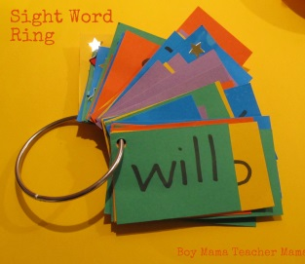
This is your child’s new Kindergarten sight word ring. Sight words are words that are often hard to read because they do not always follow phonetic rules and therefore need to be memorized by sight. They are also referred to as high frequency words because they appear often in texts. Therefore, learning how to recognize and read these basic words is an important first step in reading.
At school, sight words are introduced in context in poems and stories. We focus on one sight word each day and practice spelling it, chanting it, singing it, and finding it in our morning message or poem. We circle them, highlight them, finger paint them, make them with play dough, trace them in sand, salt, or shaving cream, and practice writing them on chalkboards, dry erase boards, in shaving cream, and build them with pipe cleaners, sticks, rocks, lego, and blocks. We also add a new sight word to our word wall each day as they are introduced and search for sight words in books, magazines, and around the school.
There are 36 Kindergarten sight words. We have broken them into 4 groups of 9. We will start everyone with the first group of 9 words. Please help your child practice their sight words regularly at home using some of the ideas below. When your child can read all of the words immediately upon sight return your child’s sight word ring to school. Your child will read their words to us and we will add the next group of 9 words to their ring to bring home.
To assist your child with learning the new words on the ring, here are a few ideas:
- Look at the words
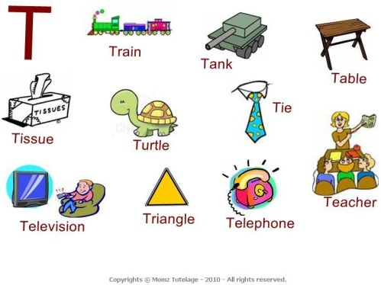
- Spell the letters aloud
- Write the word, saying the letters aloud
- Trace over the word and say each letter as it is traced
- Shut their eyes and visualize the words. Suggest to them that they make a picture of the word in their head.
- Use play dough to create the word
- Use magnetic or foam letter to create the word
- Create sentences using the words
- Finger paint the words
- Write the words in salt or sand

Your support and involvement at home is much appreciated.
Happy Reading!
The KB Kinder Team
Ms. Ferren, Ms. Hewitt, Ms. Bain

