Wednesday January 14, 2015
Dear KB Families,
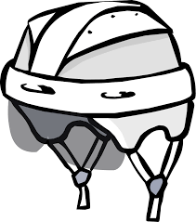
We are planning to go skating again at the Minden Arena on the following dates:
- Wednesday January 28th
- Wednesday February 11
- Wednesday February 25
- Wednesday March 11
Due to safety concerns and student ability level, we will need at least 5 volunteers each time to make our trips to the arena possible.
We will leave at 11:30 to walk to the arena and will skate from 12:00-1:00. We need help walking the children to the arena, tying children’s skates, and helping the children skate on the ice. Please let us know if you will be able to help us out on any or all of these dates.
Remember, all volunteers must have a Criminal Record Check on file in the ASES office. These are free and can be obtained easily at the ASES office but do require a 2 week processing period.
If your child needs to borrow skates and/or a helmet please let us know with a note in your child’s Note Tote. Thanks to all the generous families who brought extra gear for other children to borrow. We appreciate it immensely.
All children need to wear a helmet. Bicycle helmets are not permitted. Please make sure your child’s skates and helmets are labeled so they do not get mixed up and please pack your child’s skates and helmet in a separate bag that is easy for him/her to carry to the arena.

Thank you for making this excellent winter learning opportunity possible,
The KB Kinder Team

